**AGC ELEBANK REPLACEMENT AND INTRODUCTION LETTER RETRIEVAL**

**Exercise 1 (a): Collection of Elebank replacement**

Select the menu **“AGC” Add General Charges**

1. On event ID, use the searcher- Select elebank charges you would wish to collect as below;

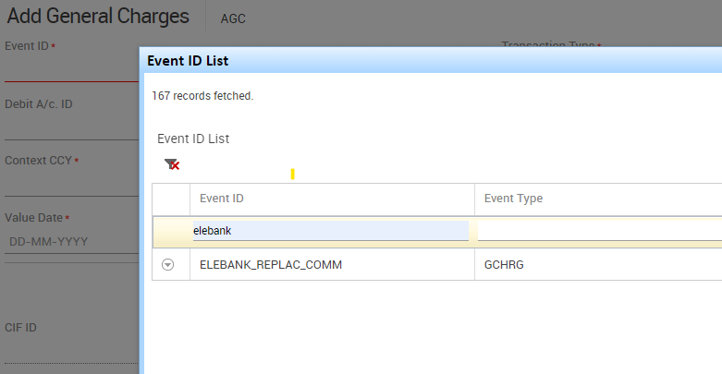

1. Enter the Debit account ID
2. Select transaction type as > transfer Bank Induced
3. Select the appropriate currency e.g KES and the value date
4. Click **On GO** to view the charges collection summary, charges collection will appear on (Calculation Amt. in Charge Debit CCY)
5. Click SUBMIT
6. Use menu IAL to confirm the transaction has been effected and the account debited as expected. Correct account will be debited and the subsequent charge deposited in the correct internal account.

**Exercise 1 (b): Collection of document retrieval charges**

Select the menu **“AGC” Add General Charges**

1. On event ID, use the searcher- Select document retrieval charges you would wish to collect as below;

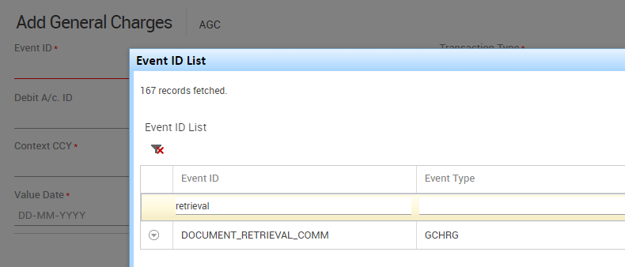

1. Enter the Debit account ID
2. Select transaction type as > transfer Bank Induced
3. Select the appropriate currency e.g KES and the value date
4. Click **On GO** to view the charges collection summary, charges collection will appear on (Calculation Amt. in Charge Debit CCY)
5. Click SUBMIT
6. Use menu IAL to confirm the transaction has been effected and the account debited as expected. Correct account will be debited and the subsequent charge deposited in the correct internal account.